**Med-Bay**

**A Project Report**

***Submitted by***

**Vrushit Patel**

***Under the Guidance of***

Prof. Vijayetha Thoday

***in partial fulfillment for the award of the degree of***

## B. Tech (Computer Engineering)

**At**



**MPSTME, Mumbai**

**Nov, 2020**

**DECLARATION**

I, Vrushit Patel, Roll No. E006 B. Tech (Computer Engineering), V semester understands that plagiarism is defined as anyone or combination of the following:

1. Un-credited verbatim copying of individual sentences, paragraphs or illustration (such as graphs, diagrams, etc.) from any source, published or unpublished, including the internet.
2. Un-credited improper paraphrasing of pages paragraphs (changing a few words phrases, or rearranging the original sentence order)
3. Credited verbatim copying of a major portion of a paper (or thesis chapter) without clear delineation of who did wrote what. ( Source: IEEE, The institute, Dec. 2004)
4. I have made sure that all the ideas, expressions, graphs, diagrams, etc., that are not a result of my work, are properly credited. Long phrases or sentences that had to be used verbatim from published literature have been clearly identified using quotation marks.
5. I affirm that no portion of my work can be considered as plagiarism and I take full responsibility if such a complaint occurs. I understand fully well that the guide of the seminar/ project report may not be in a position to check for the possibility of such incidences of plagiarism in this body of work.

Name: Vrushit Patel

Roll No. : E006

Place: Mumbai

Date: 03/11/2020

**CERTIFICATE**

This is to certify that the project entitled “Med-Bay” is the bonafide work carried out by Vrushit Patel of B.Tech. , MPSTME (NMIMS), Mumbai, during the V semester of the academic year 2020-21, in partial fulfilment of the requirements for the Course Programming Language.

___________________

Prof. Vijayetha Thoday

Internal Mentor

_______________________ ________________________

Examiner 1 Examiner 2

**TABLE OF CONTENTS**

|  |  |  |
| --- | --- | --- |
| CHAPTER NO. | TITLE | PAGE NO. |
| 1. | PROJECT INTRODUCTION | **5** |
| 2. | MODULES IMPLEMENTED | **5** |
| 3. | SCREENSHOTS | **5** |
| 4. | CONCLUSION & FUTURE SCOPE | **17** |
| 5. | SOCIETAL APPLICATION (If any) | **17** |

**PROJECT INTRODUCTION**

MedBay is all about finding best doctors and hospitals in our surrounding areas. It also provides information related to the Covid-19 Symptoms and Precautions to be taken. Doctors can also write daily blogs and post it on the website, so that other people can see their Blogs. MedBay provides easy filling up of Appointment Form, so clients can fill up the form to book their appointments with their doctors.

**MODULES IMPLEMENTED**

There are many modules implemented in the project. The modules are listed below:

* Log-in for doctors.
* Book Appointment Form
* Covid-19 Test Form
* Search Doctor
* Filter Doctor By Area Or Speciality Or Both
* Search Hospital
* Filter Hospital By Area Or Speciality Or Both
* Write A Blog As A Doctor
* I used many JavaScript files
* I used 19-20 PHP files
* Have 80 doctor’s database
* Have 40-50 hospital’s database

**SCREENSHOTS**

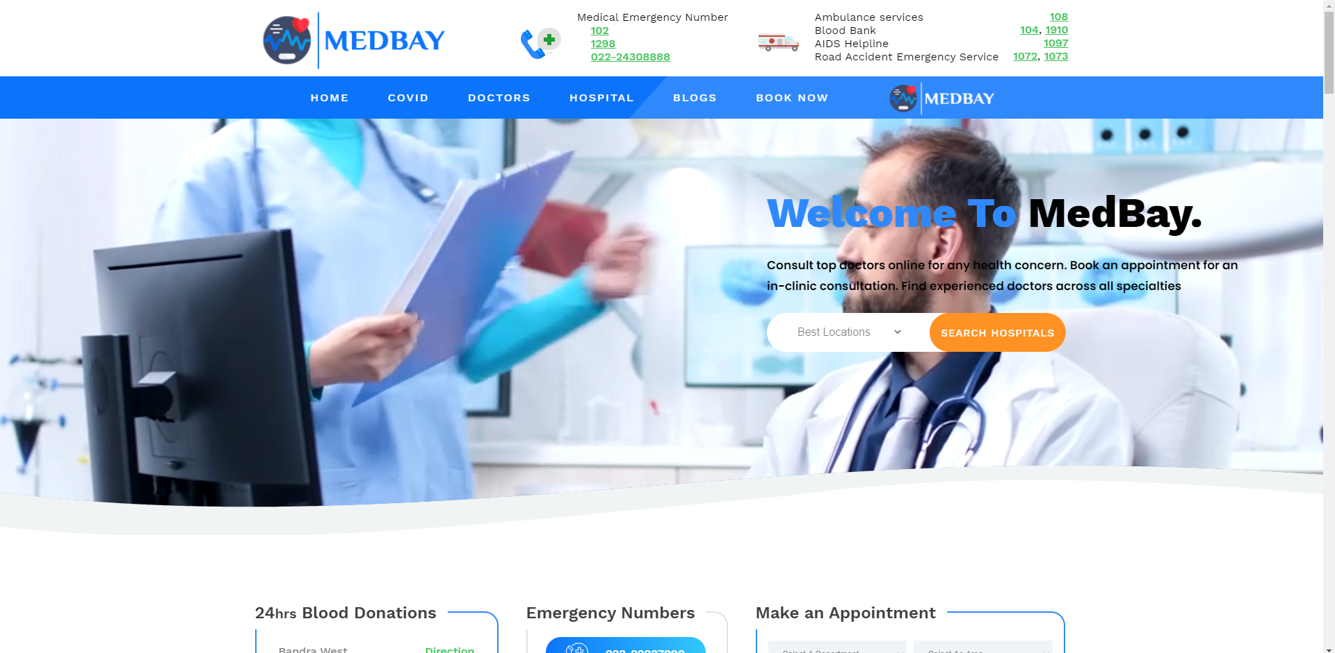

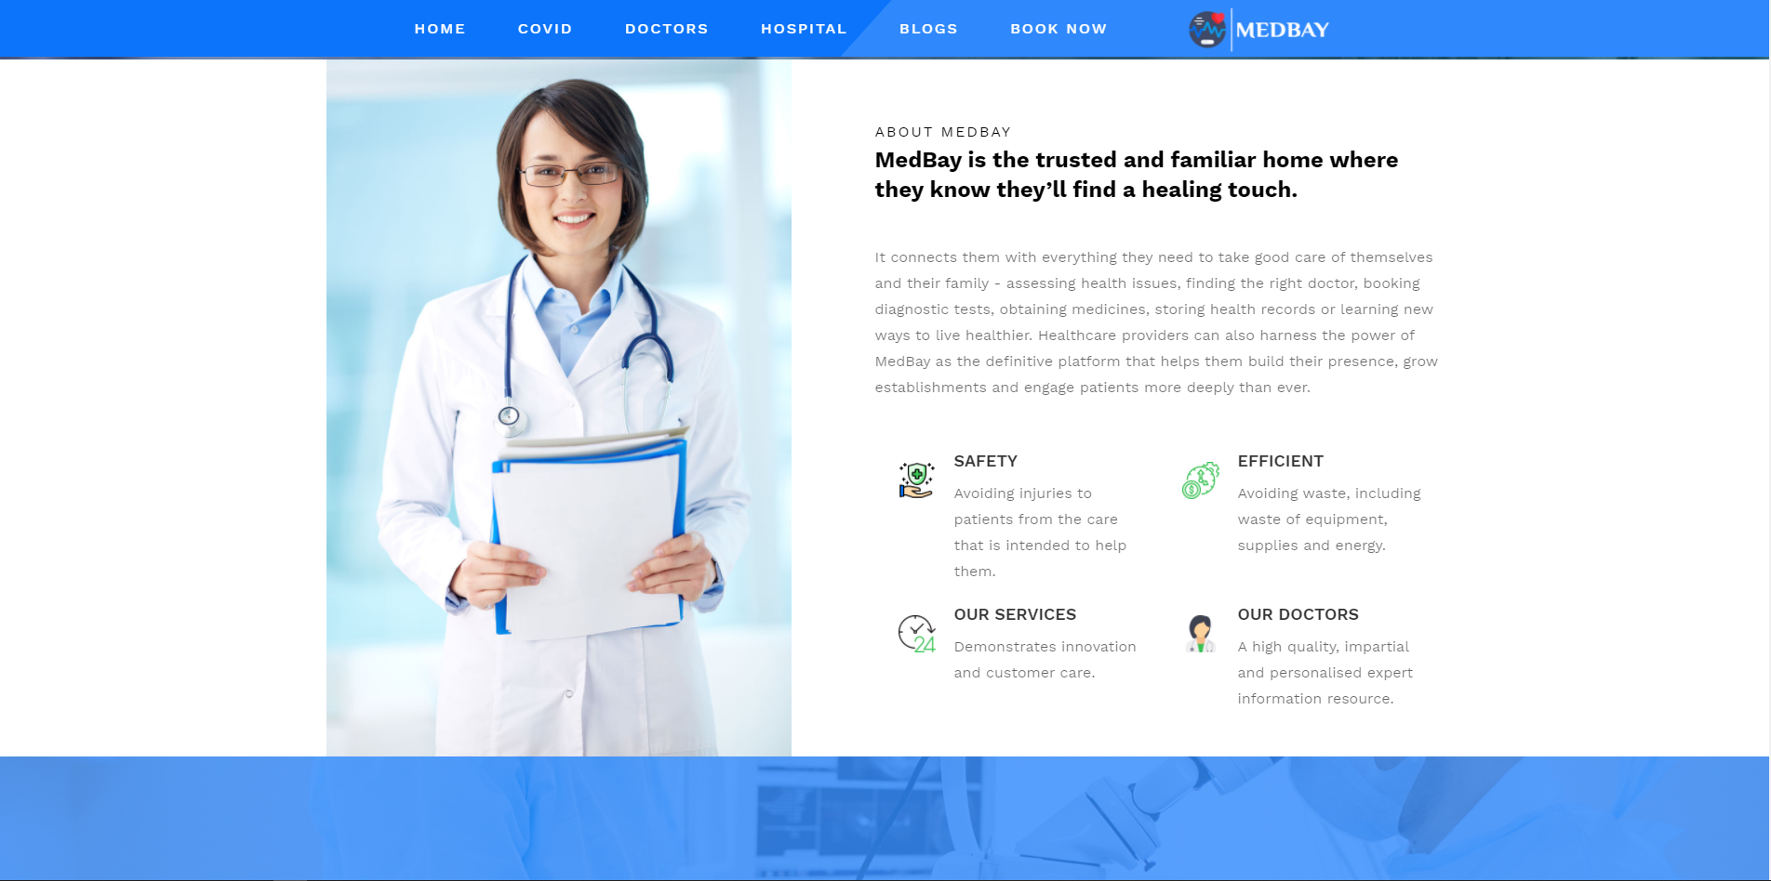

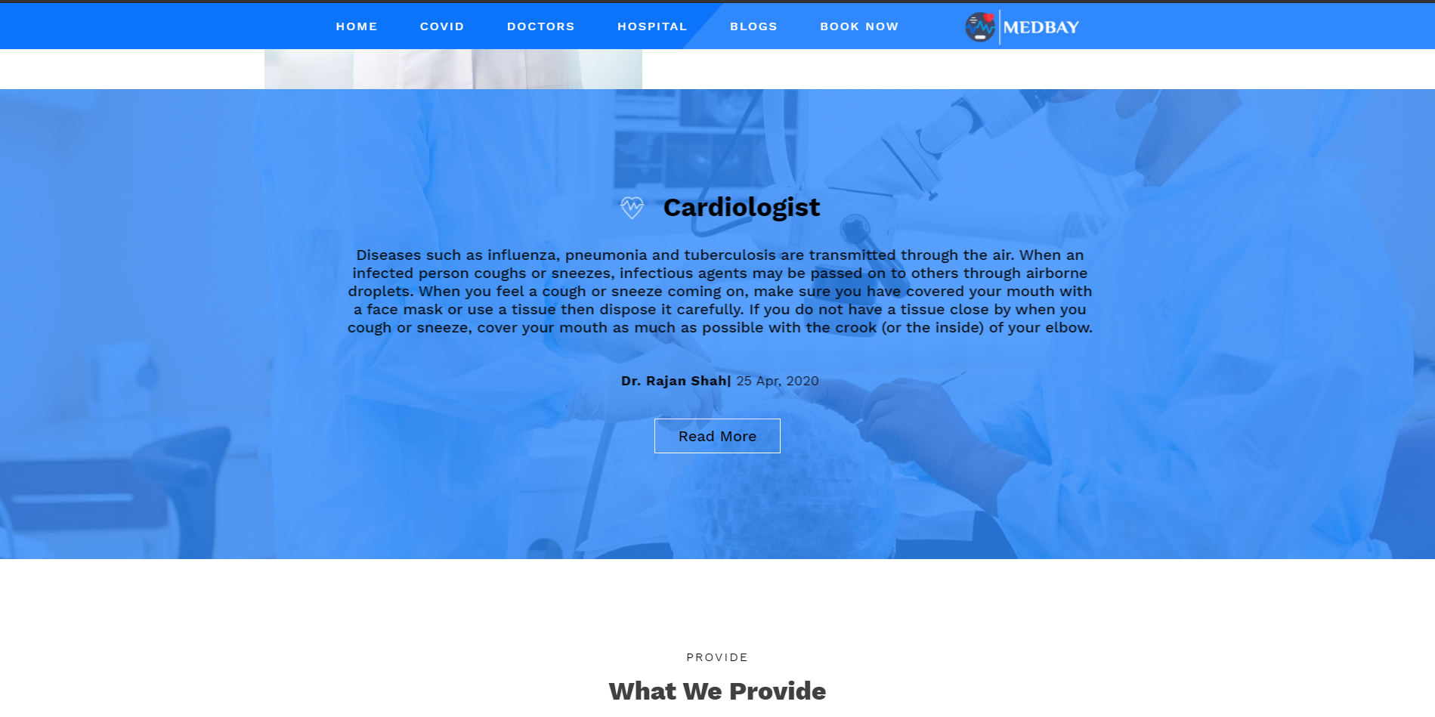

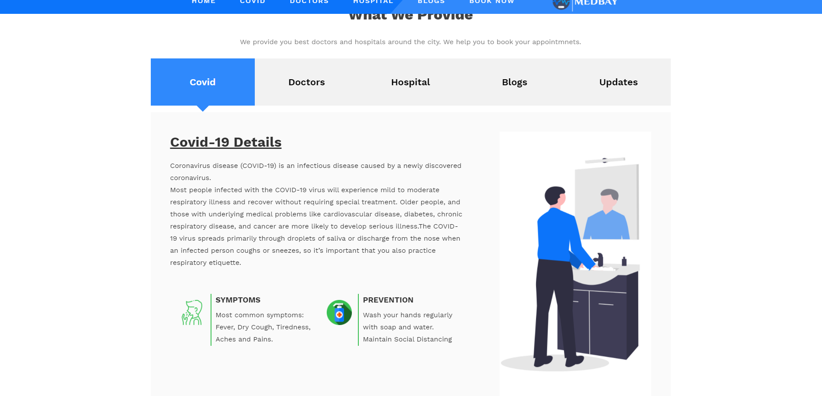

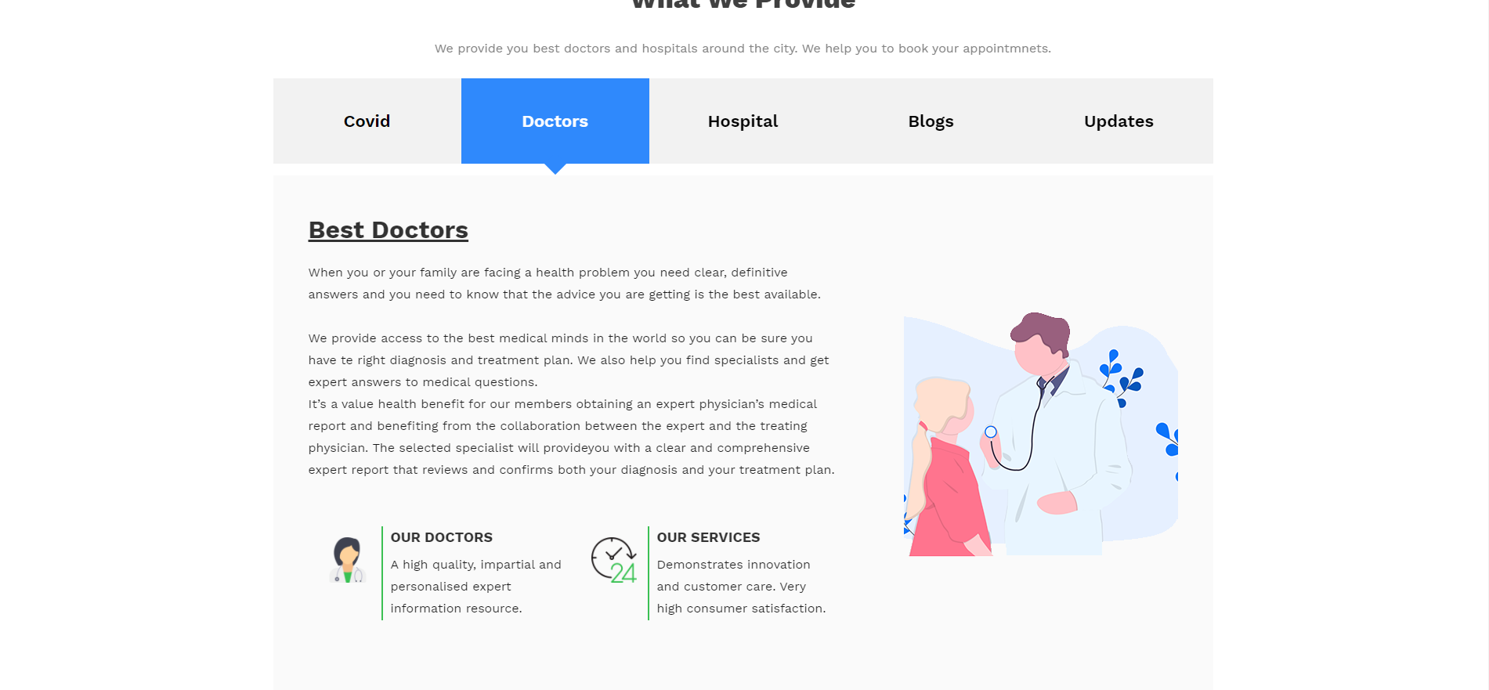

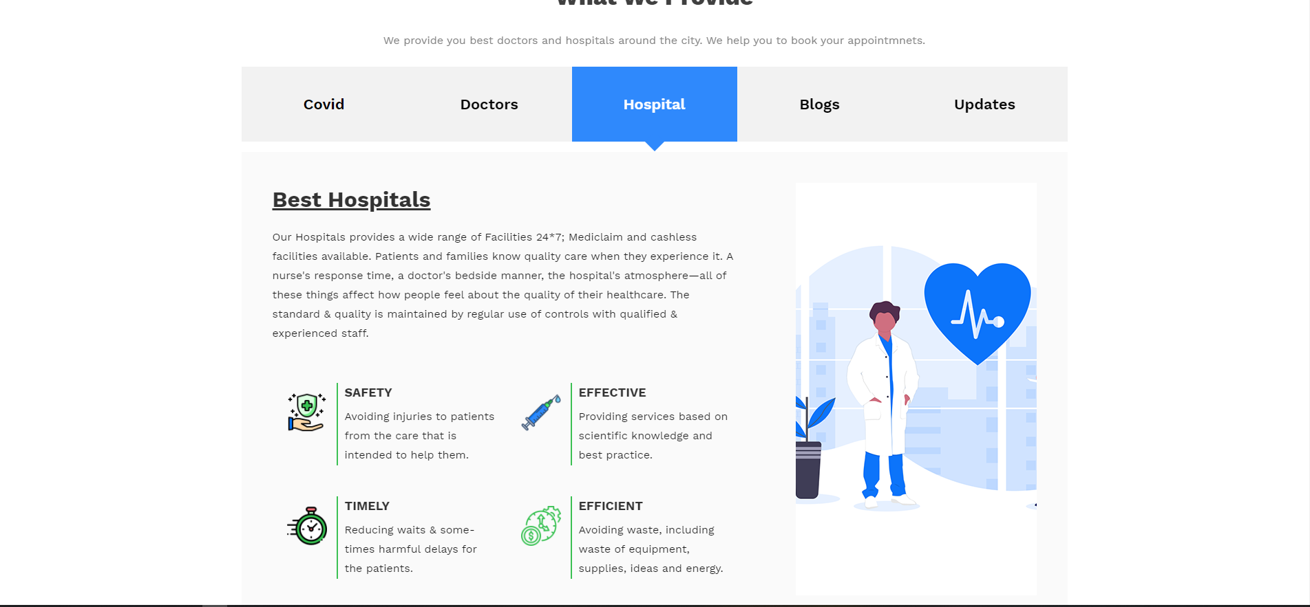

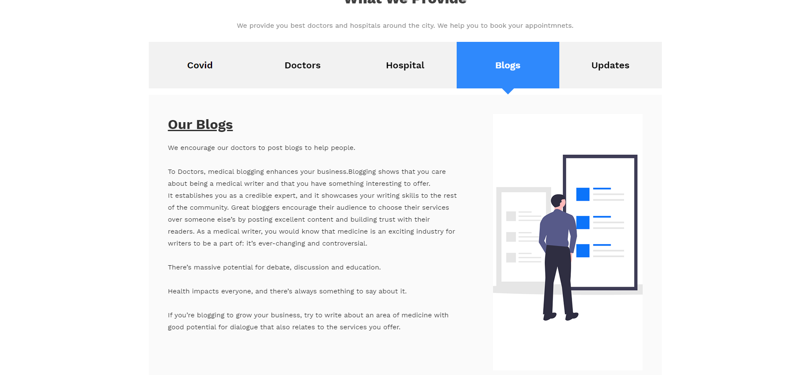 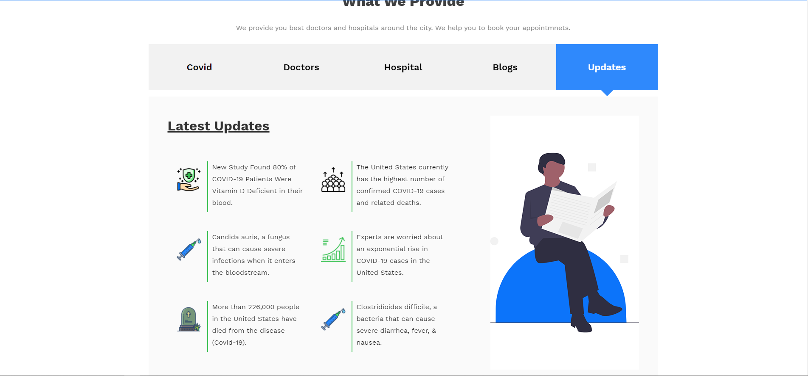

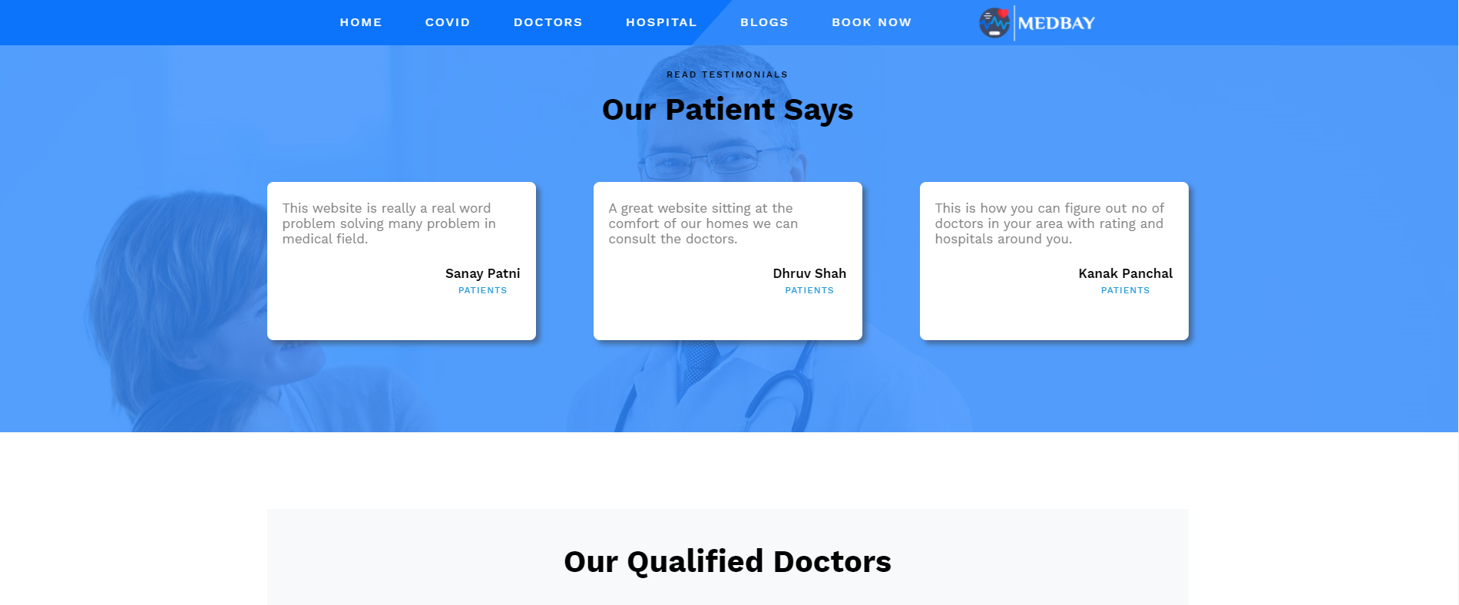 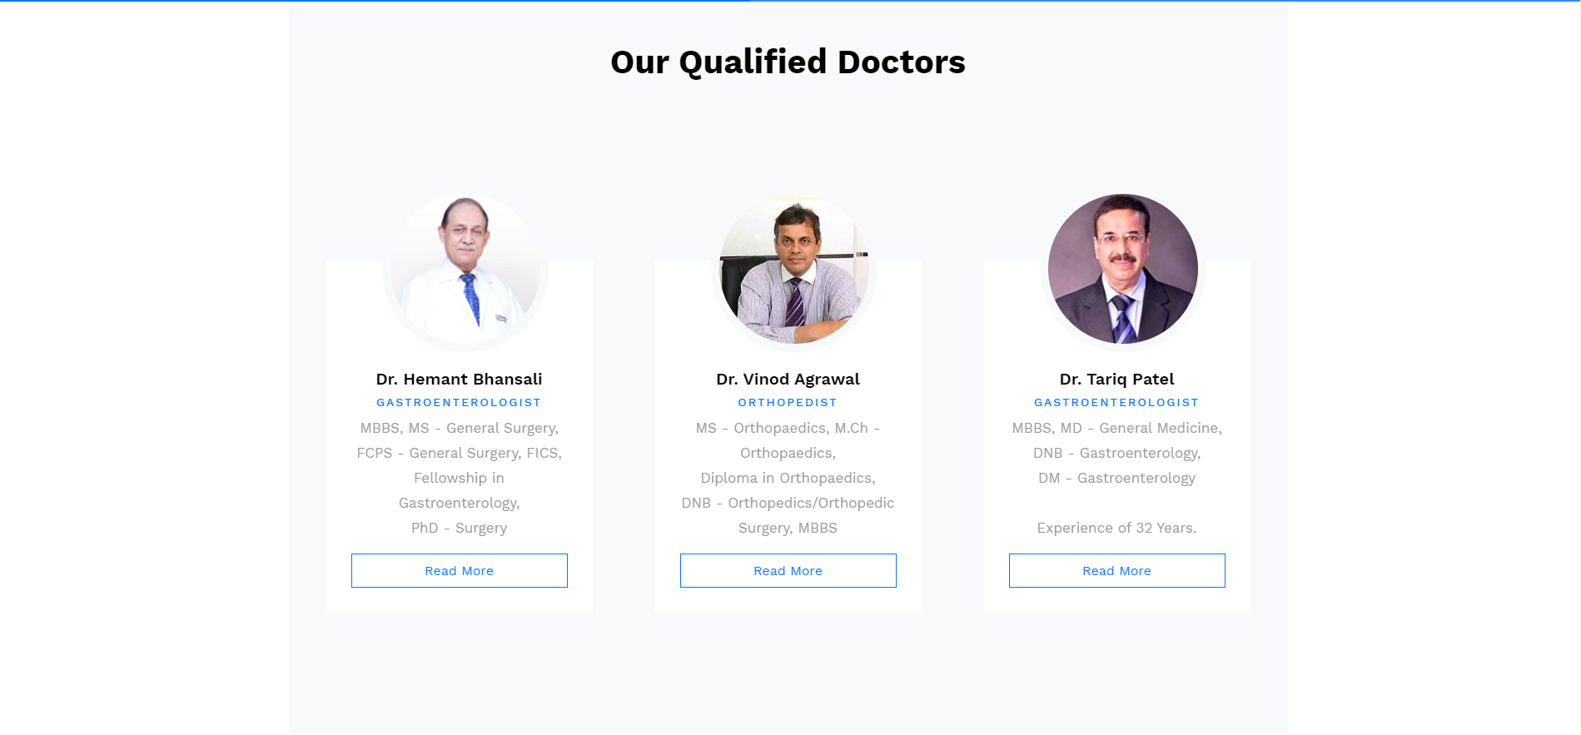

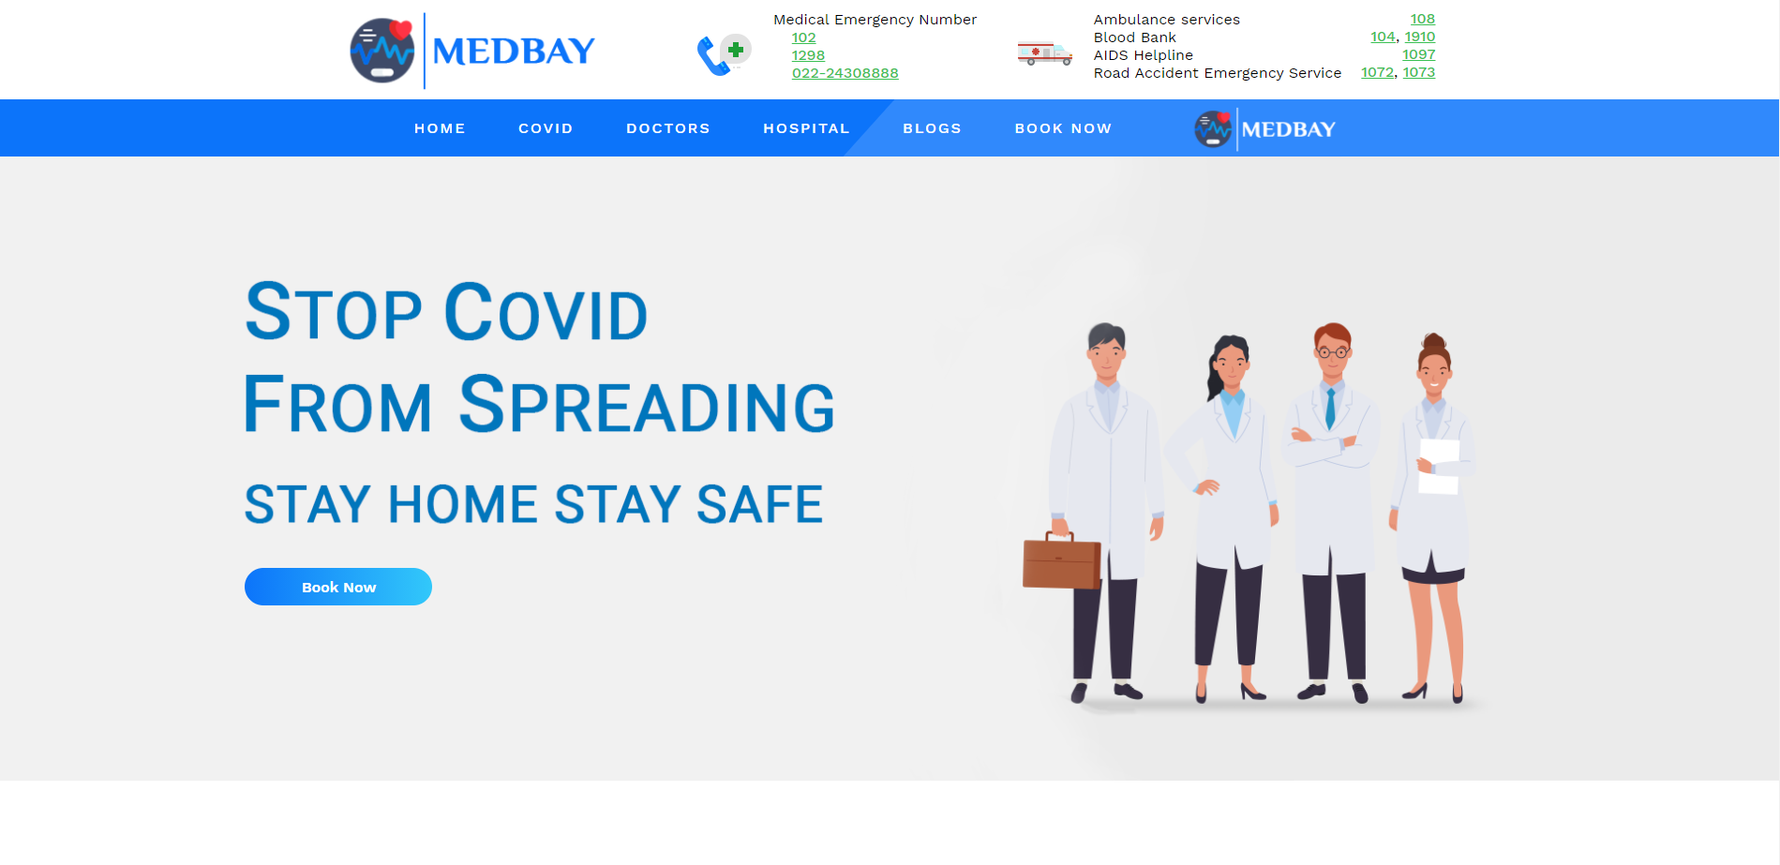 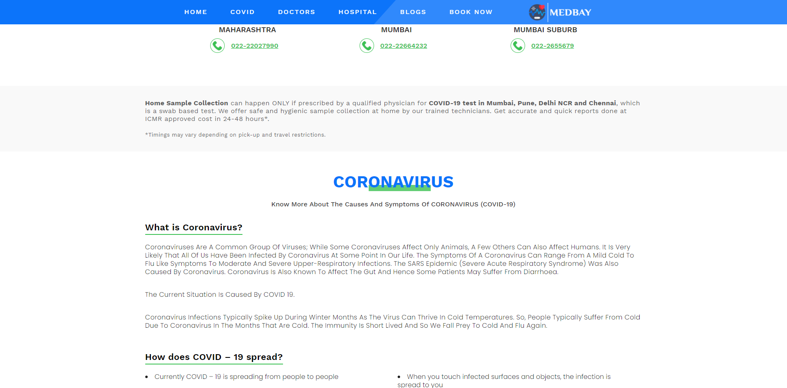 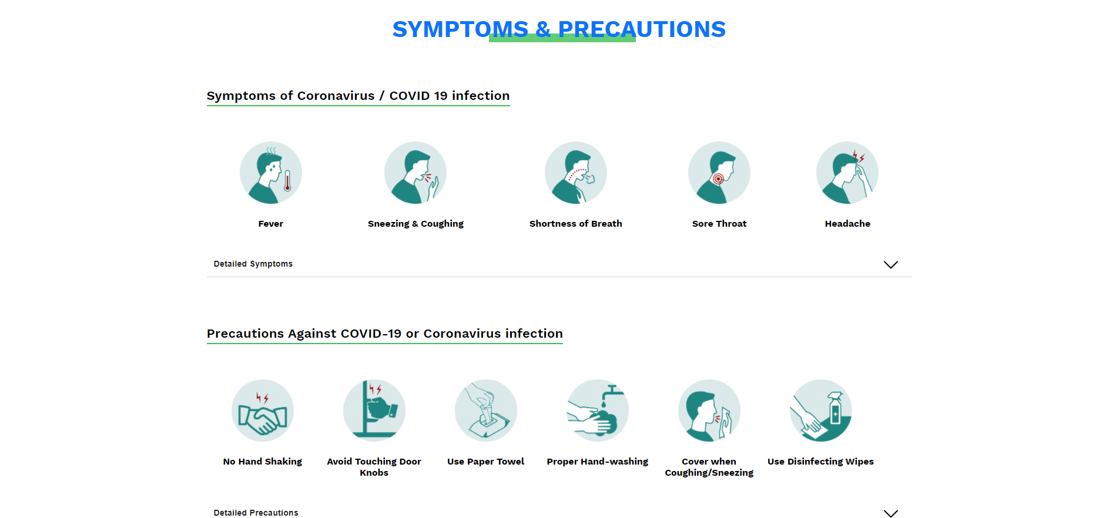 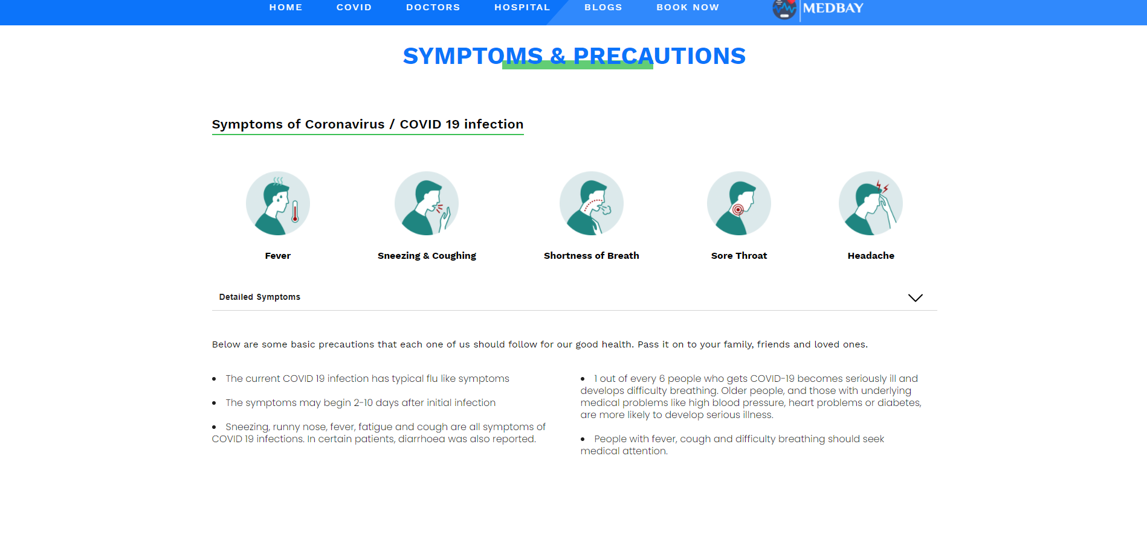 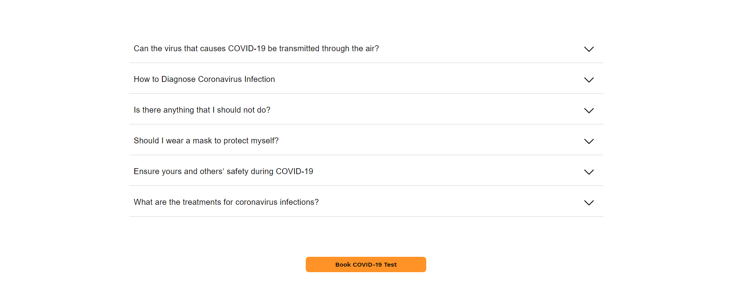 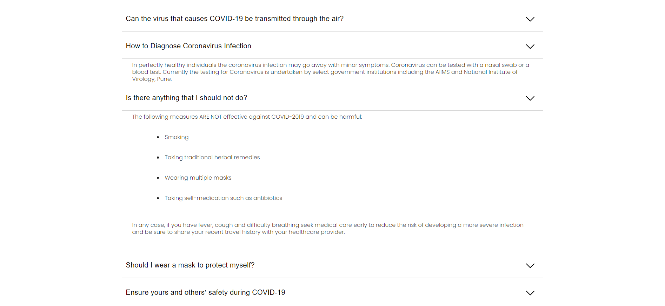 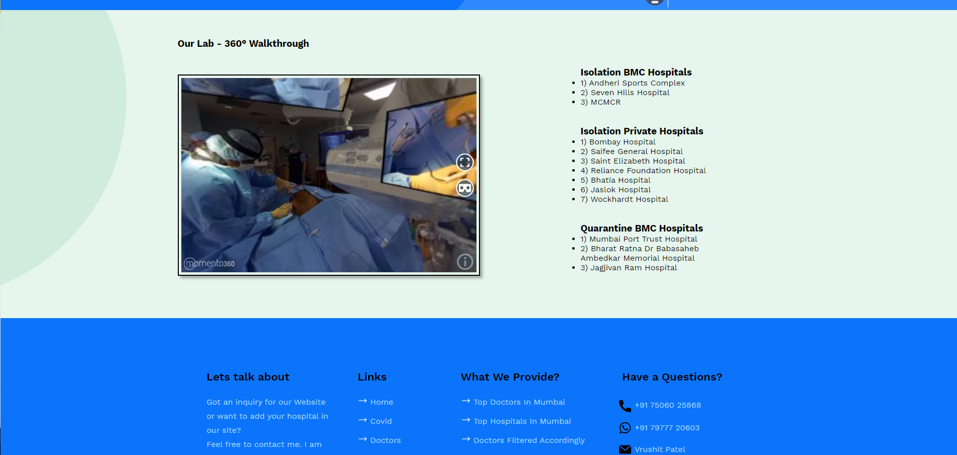 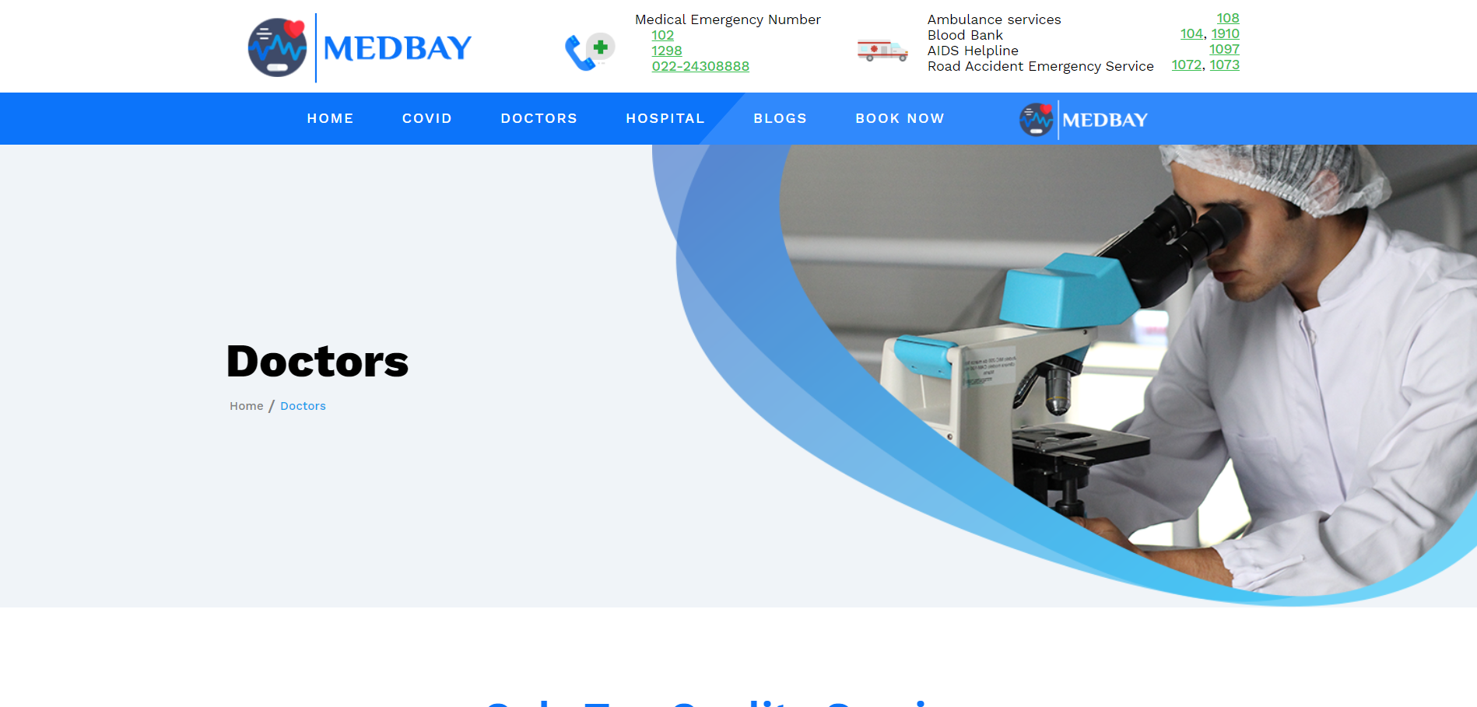 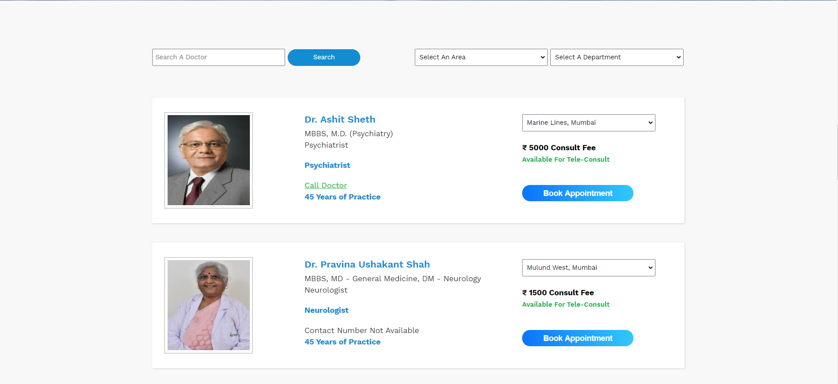 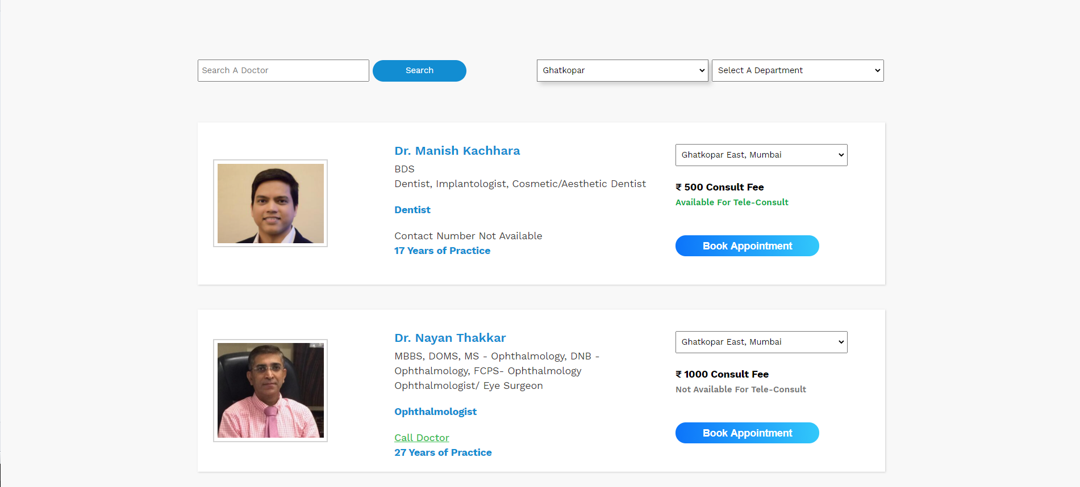 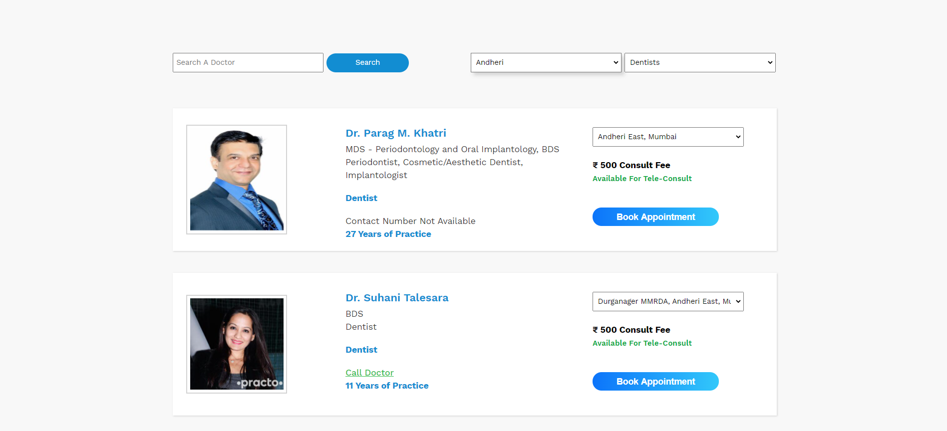 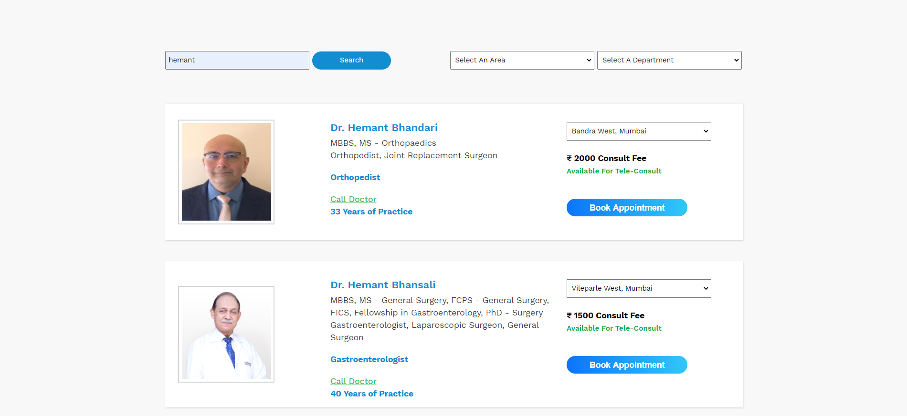 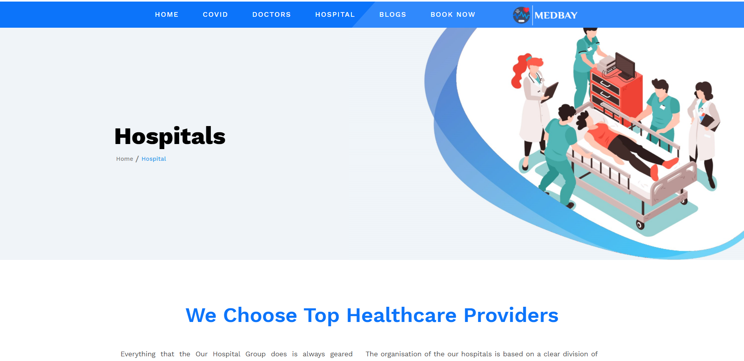 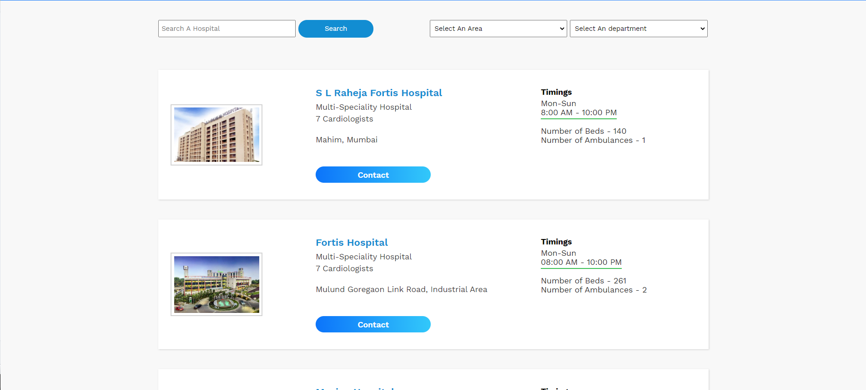 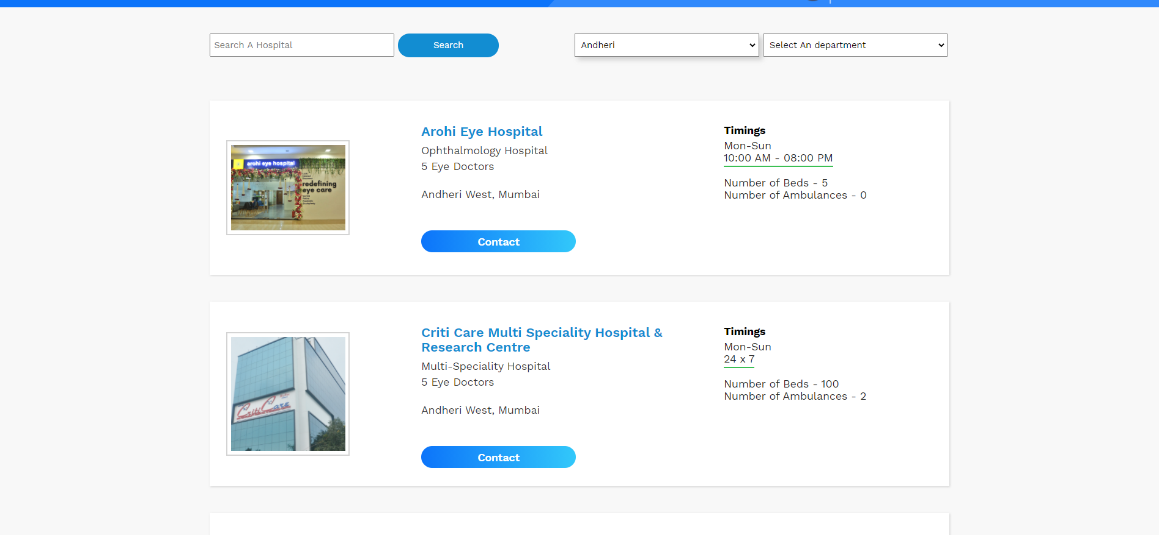 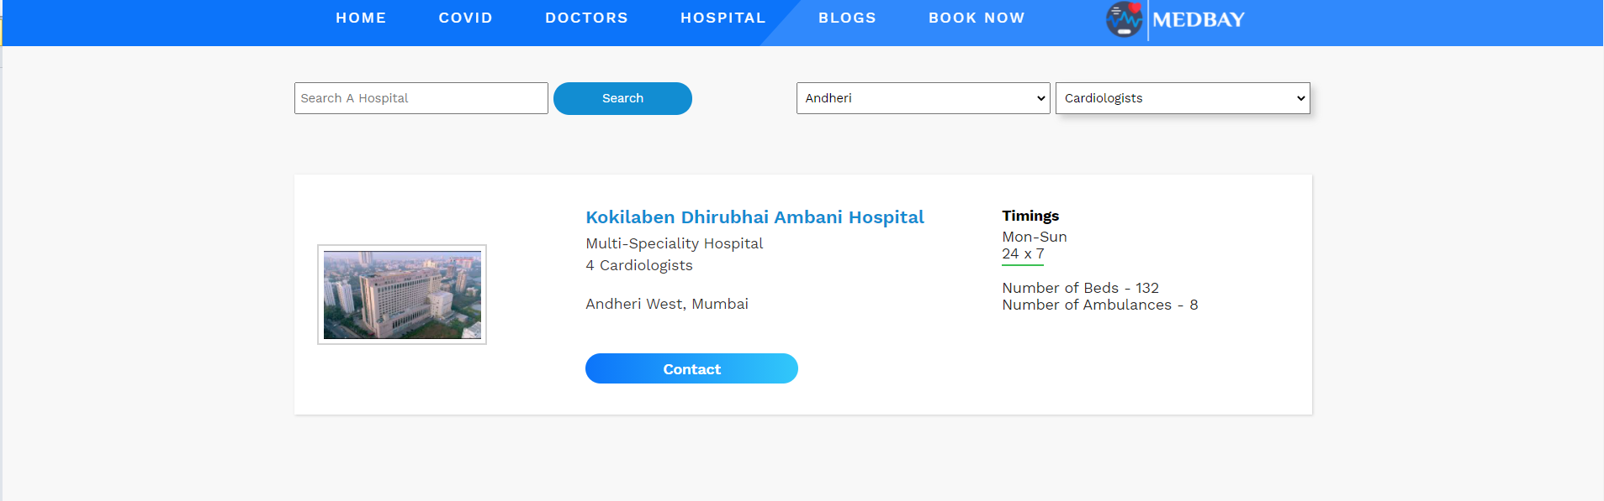 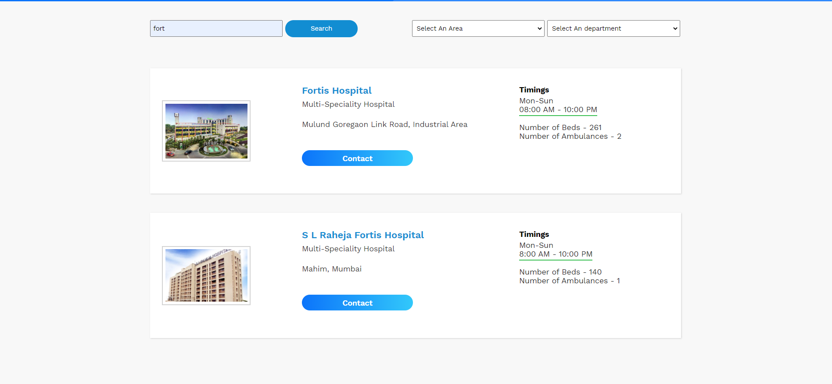 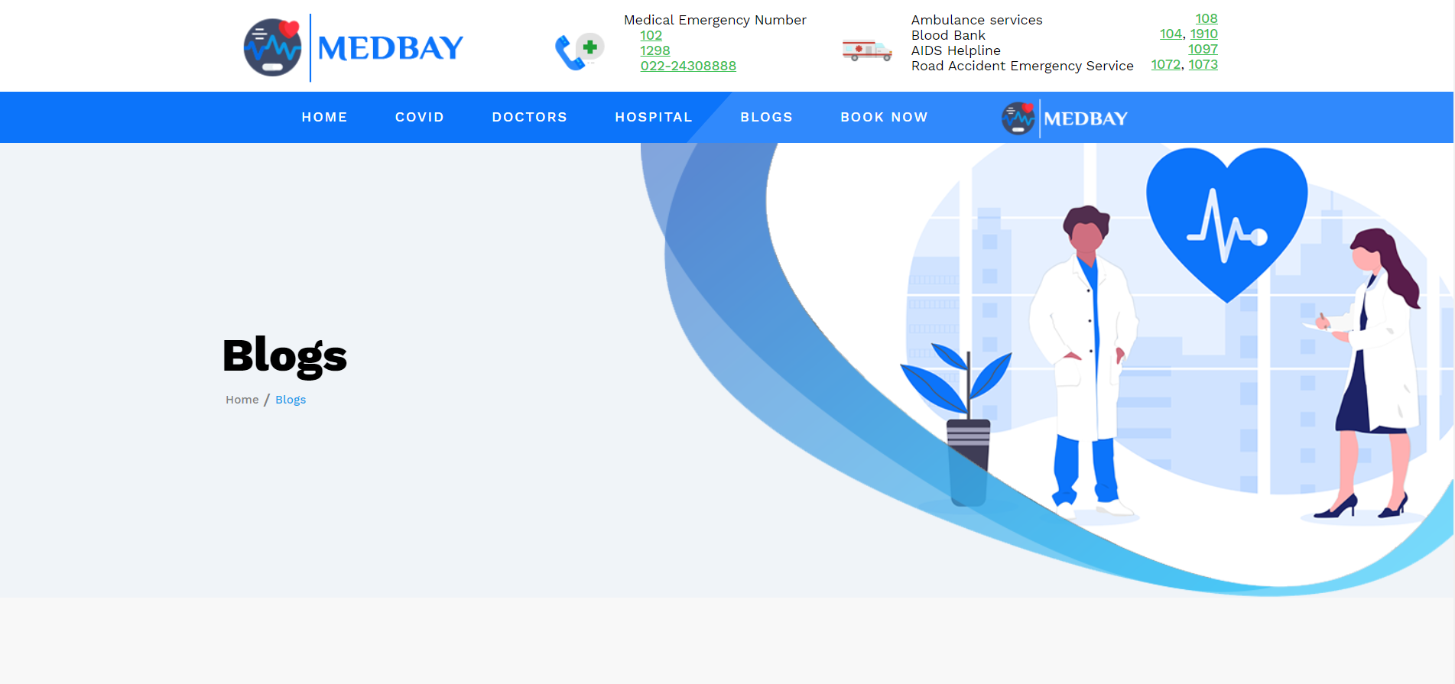

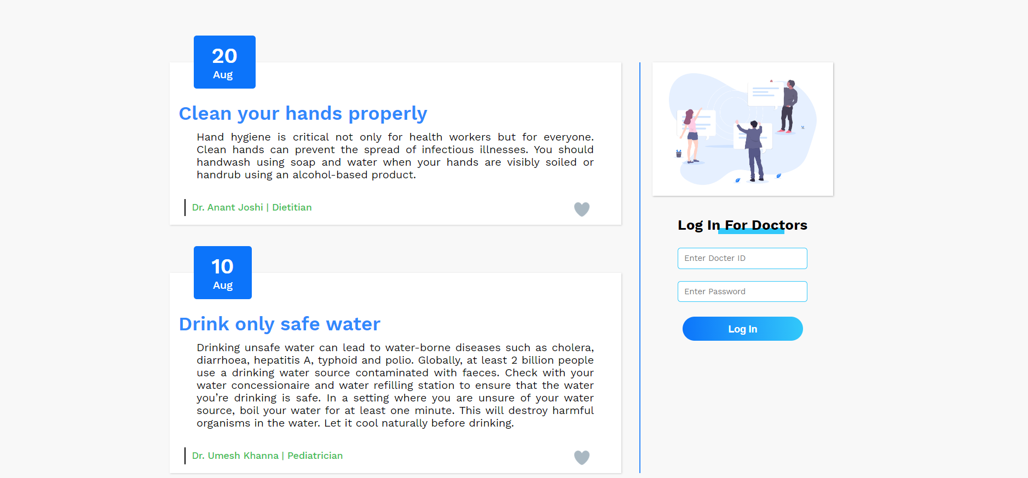

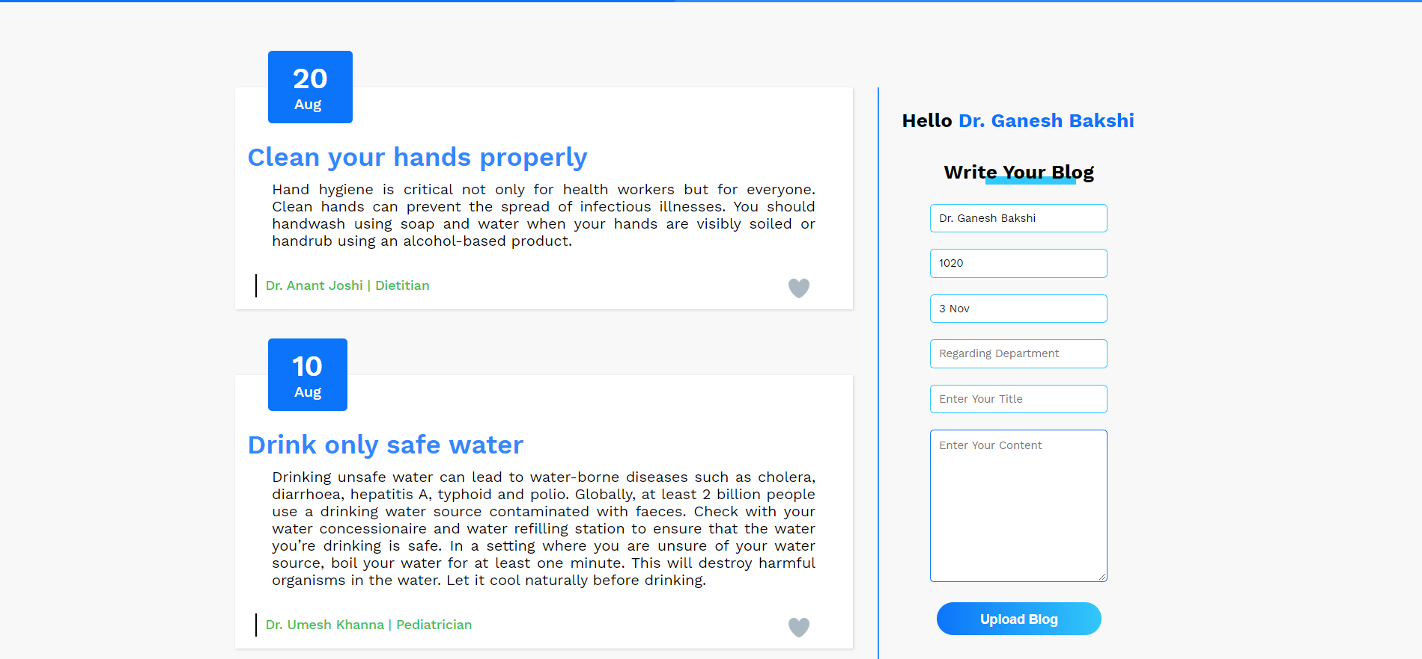

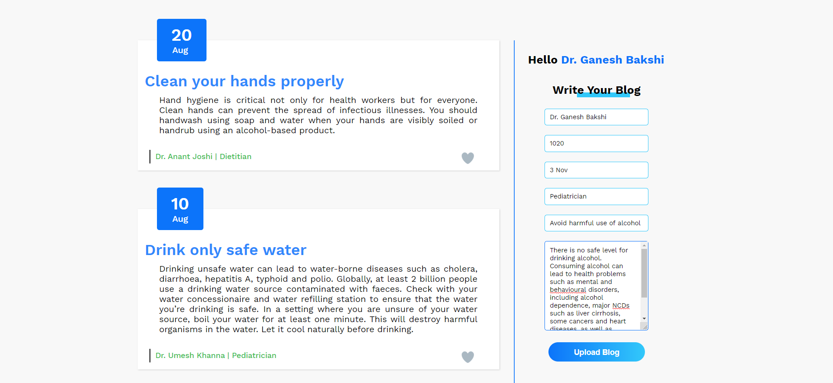

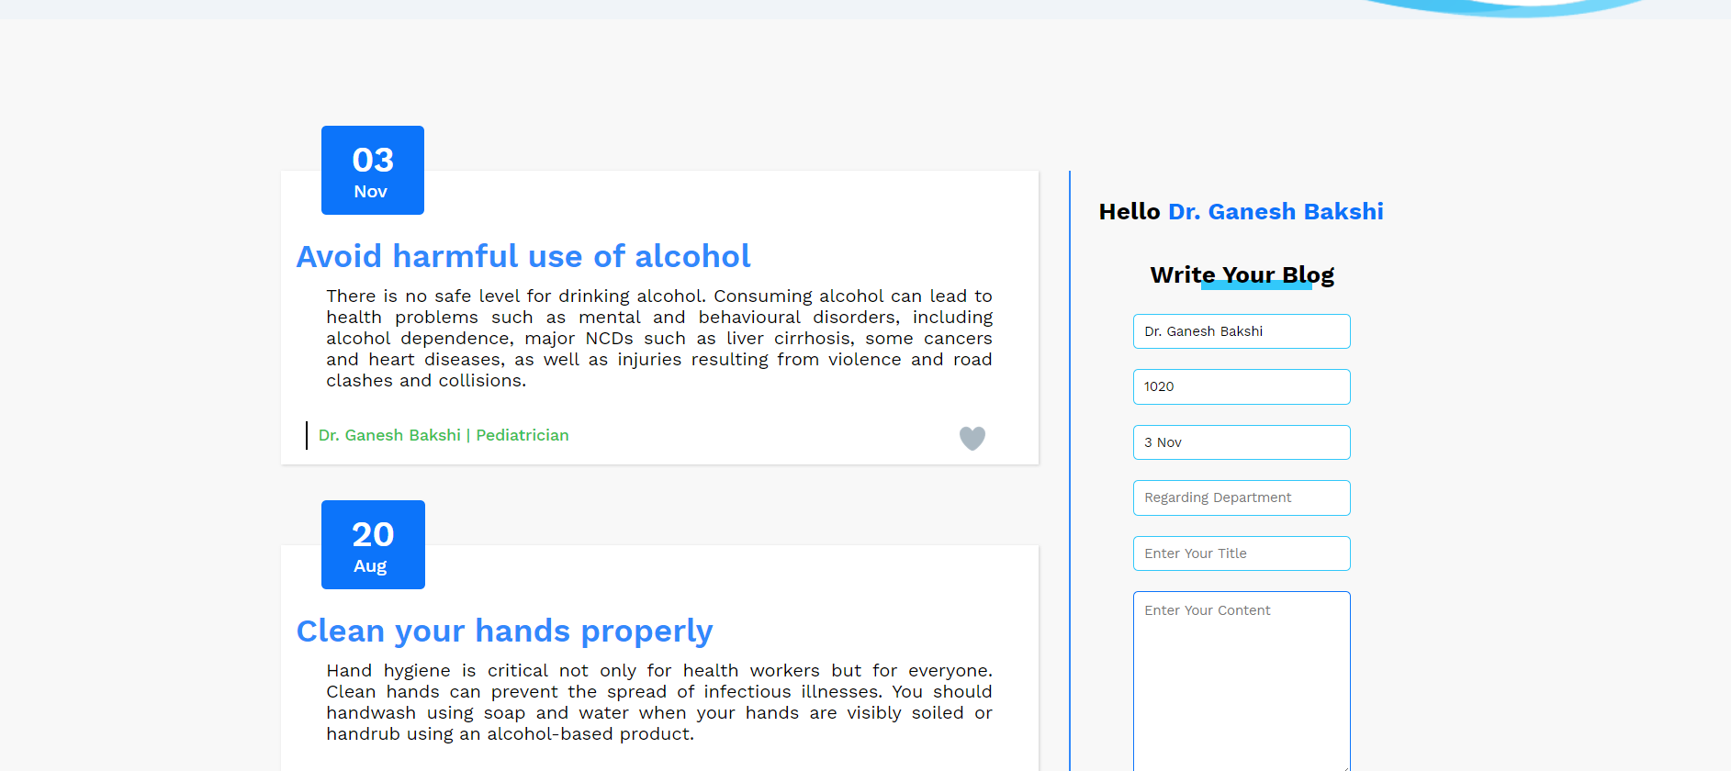

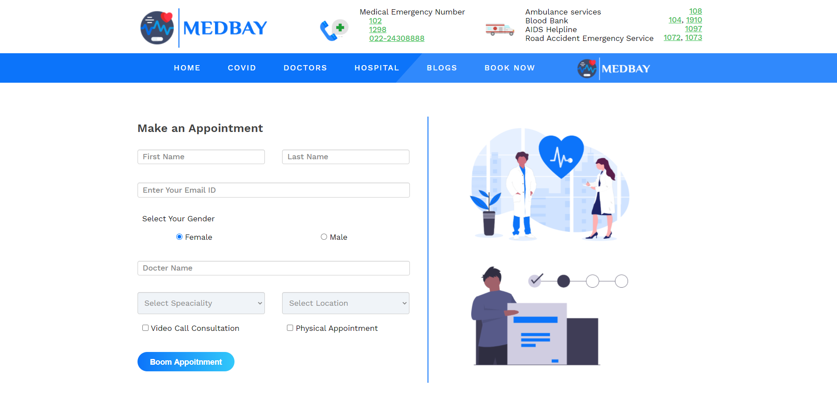

**CONCLUSION & FUTURE SCOPE**

MedBay Project helped me to learn PHP and AJAX. It also helped me learn more of Javascript how we can use in real websites. The most difficult part of the project was to display content without refreshing the whole page.

For future we can build a whole community tab for specialist doctors and patients so that they can talk and seek for some good advises. We can also put a form where doctors can request to make their account in our website.

**SOCIETAL APPLICATION**

There no such societal applications but people can come to my website to find some good doctors and hospitals in their area. And one is that doctor can give some advises by posting their blogs on MedBay.



**Thank You!!**